**Python Installation Steps**

1. **Installation of anaconda:**

Open : <https://www.continuum.io/downloads>

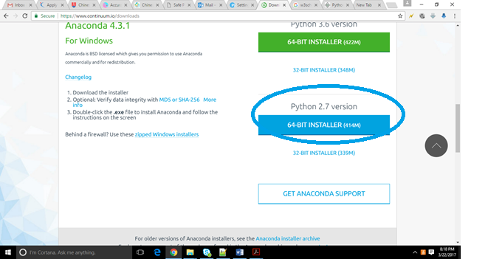

Download python 2.7 version anaconda(highlighted with blue circle). 64 bit/32 bit installer based on your computer configuration.

Note: Do not download python 3.6 version Anaconda.

Double click .exe file to install

Complete the installation by clicking Next button.

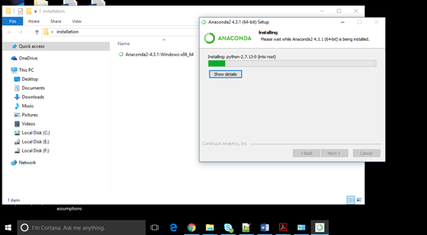

1. **Open Ipython notebook (IDE):**

Once installation is done, Open cmd prompt:

Enter cmd: ipython notebook

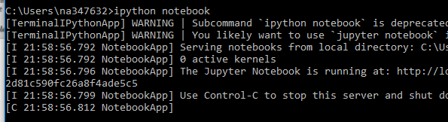

Note: Observe that new browser opens. It looks as shown below

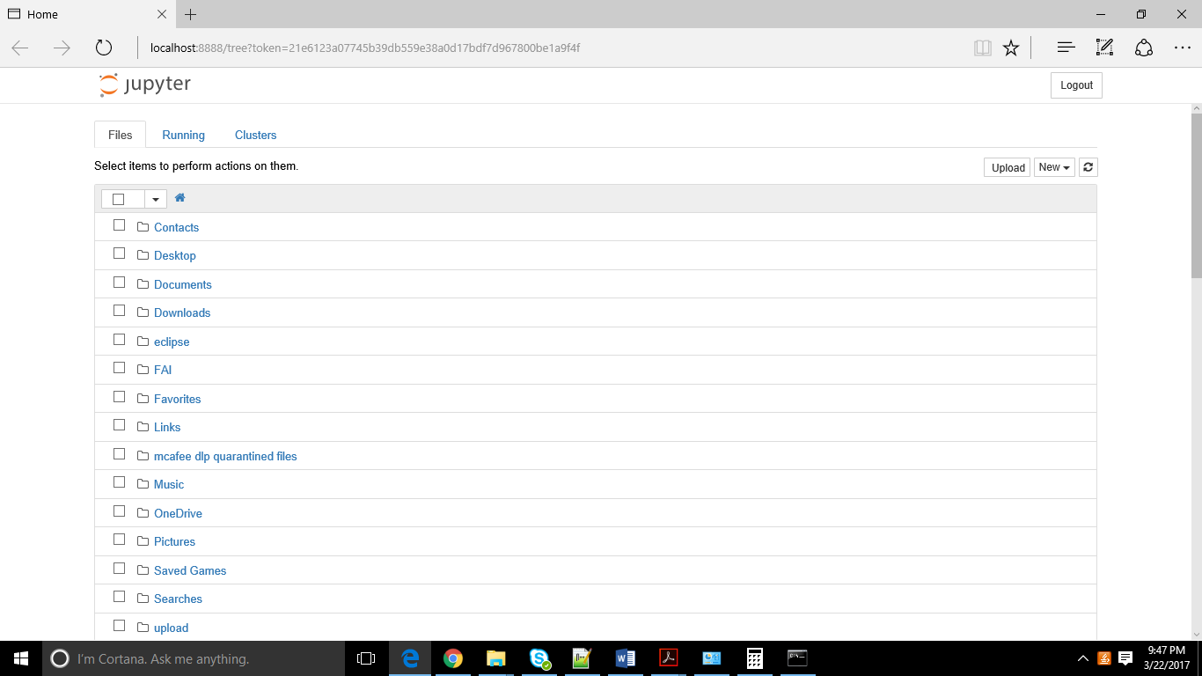

Click new->python2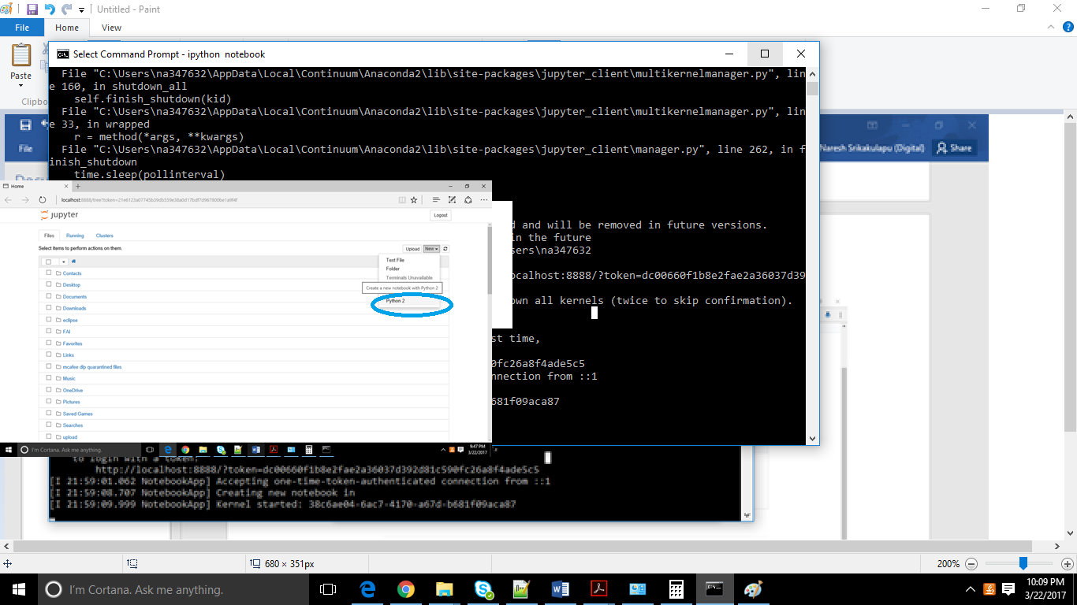

New browser opens as shown below (interactive python IDE)

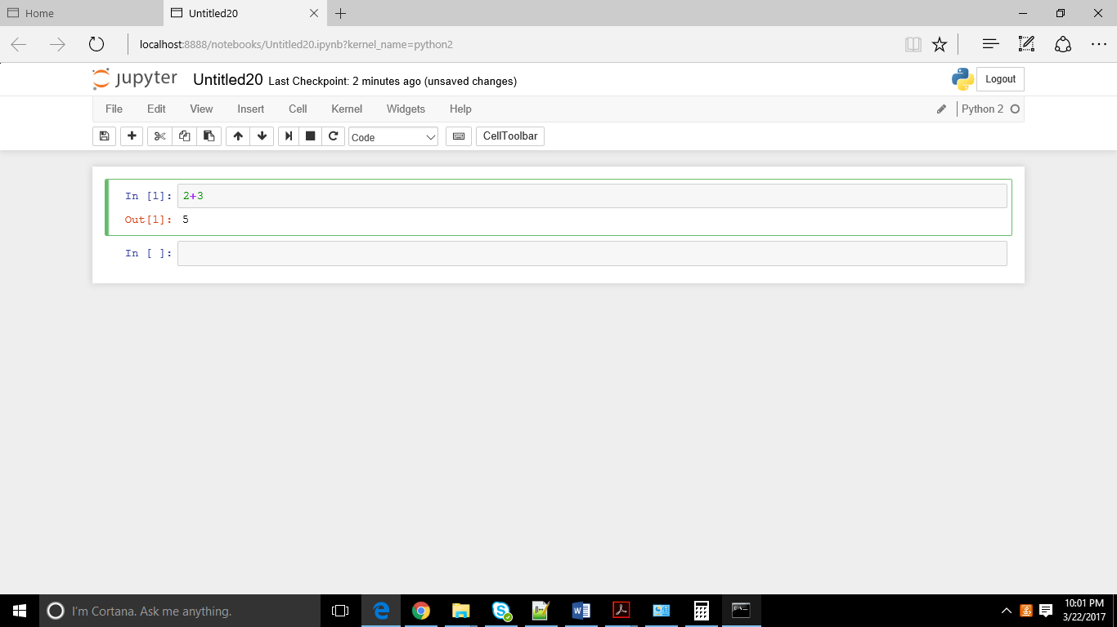

* The interface shows In [*] for inputs and Out[*] for output.
* You can execute a code by putting curser on **In[ ]** and click highlighted button as shown in below image

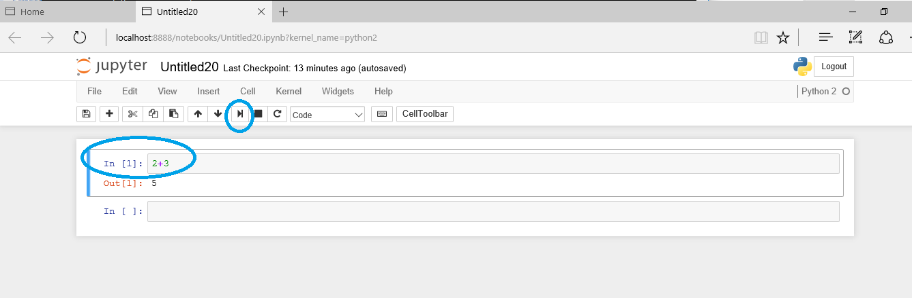

Start practicing python basics on this tool/IDE.

We will be using this IDE through out this course. In fact in your Project also.

Note: Anaconda is a package which come with most of Machine learning libraries. It avoids installing library separately.